FOR SALE
Lot #221
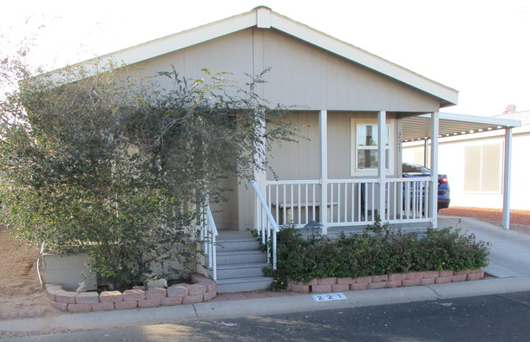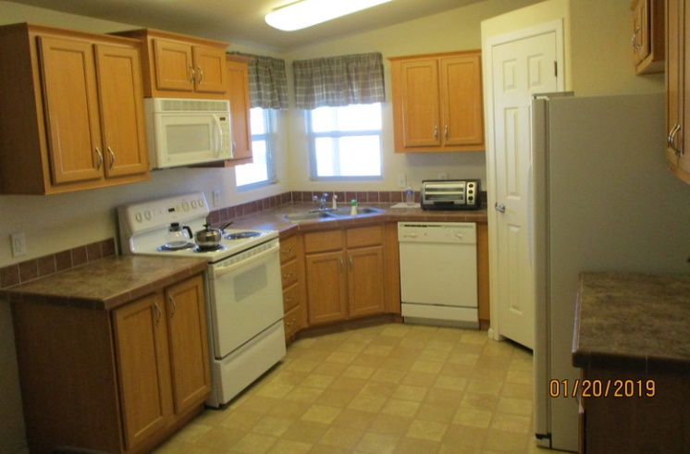

Contempo Tempe
2609 W. Southern Ave.
Tempe, AZ 85282

$64,900 with or without furniture

3 Beds, 2 Baths
2006 Clayton
1,250 sq. ft.
24' X 56' includes front porch
Carport with ramped driveway
Cement Board Siding
Tape & Texture Throughout
Vaulted Ceilings
Dual Pane Windows
All Electric/Heat/AC
All Appliances Stay
Large Kitchen Pantry
No Homes Behind
Pet Friendly
55+ Senior Park
Close to Freeways and Airport

Call Chuck Berg 602-454-6717 | 480-682-7299 cell

